Payday 2 Character Setup

Created by Michael O'Rourke

Table of Contents

Executive Summary…...............................................................................................................................3
Entity Relationship Diagram…..................................................................................................................4

Tables: Create statements and Sample data…...........................................................................................5
Users….......................................................................................................................................................5
Character Level..........................................................................................................................................5
Bonus Chosen............................................................................................................................................6
Inventory....................................................................................................................................................7
Skill Deck...................................................................................................................................................8
Perk Deck...................................................................................................................................................8
Skill Deck Specifics...................................................................................................................................9
Perk Deck Specifics.................................................................................................................................10
Primary Weapon.......................................................................................................................................11
Secondary Weapon...................................................................................................................................12
Melee........................................................................................................................................................13
Grenade....................................................................................................................................................13
Armor ......................................................................................................................................................14
Equipment................................................................................................................................................14
Mask.........................................................................................................................................................15

Views........................................................................................................................................................16
Queries.....................................................................................................................................................17
Stored Procedures....................................................................................................................................18

Security.....................................................................................................................................................19

Implementation Notes..............................................................................................................................20
Known Problems......................................................................................................................................20
Future Enhancements...............................................................................................................................21

Executive Summary

With this document the design and implementation of the Payday 2 Character Setup can be explained and worked through in a simple and efficient manner. The Payday 2 Character Setup helps to clarify and explain what options the user has when getting ready for their next big heist.
The Entity Relationship Diagram (E/R Diagram) gives a visual representation of the database table organization and connections. The E/R Diagram is the basis in which the database was structured and formed and was referenced during the creation of the database.
This document additionally references current problems with the database and future goals. These are problems and enhancements to fix in later updates.

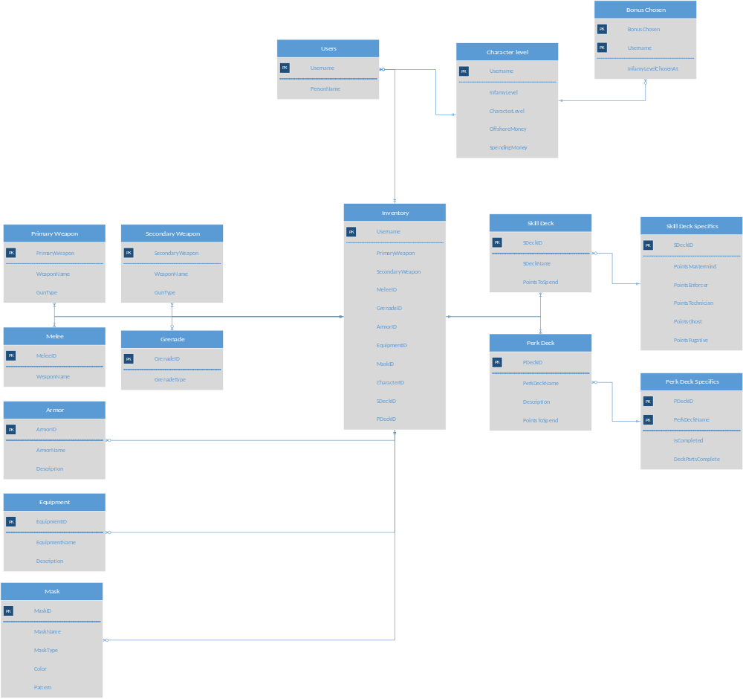
Entity Relationship Diagram

Tables

Users
This is a simple table holding the username and the real name of the players.

Create Table Users (
Username text Not Null,
PersonName text Not Null,
Primary Key(Username)
);

Functional Dependencies are based on Username as it is the primary key.

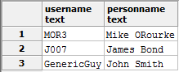

Character Level

Create Table Character_Level (
Username text Not Null,
InfamyLevel int Not Null,
CharacterLevel int Not Null,
OffshoreMoney int Not Null,
SpendingMoney int Not Null,
Primary Key(Username)
);

The Functional Dependencies are based on Username as it is the primary key.

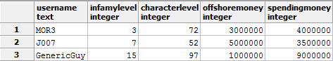

Bonus_Chosen

Create Table Bonus_Chosen (
BonusChosen text Not Null,
Username text Not Null,
InfamyLevelChosenAt int Not Null,
Primary Key (BonusChosen, Username)
);

The Functional Dependencies are based on a composite key of BonusChosen and Username as both are important to document what bonus was chosen at what level.

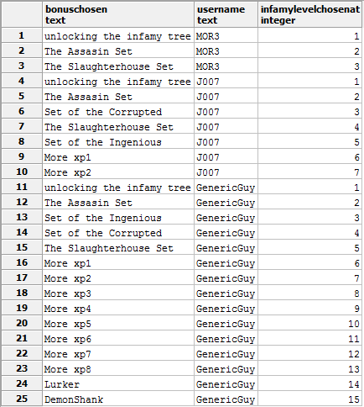

Inventory

Create Table Inventory (
Username text Not Null,
PrimaryWeapon text Not Null,
SecondaryWeapon text Not Null,
MeleeID text Not Null,
GrenadeID text Not Null,
ArmorID text Not Null,
EquipmentID text Not Null,
MaskID text Not Null,
CharacterID text Not Null,
SDeckID text Not Null,
PDeckID text Not Null,
Primary Key(Username)
);

The Functional Dependencies are based on Username as it is the primary key which holds the active selections for the user.

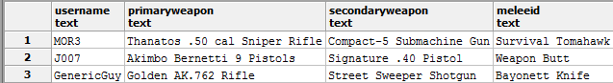
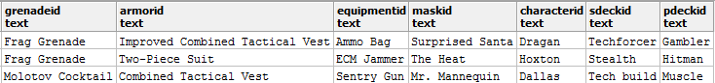

Skill Deck

Create Table Skill_Deck (
SDeckID text Not Null,
SDeckName text Not Null,
PointsToSpend int Not Null,
Primary Key(SDeckID)
);

The Functional Dependencies are based on SDeckID as it is the primary key
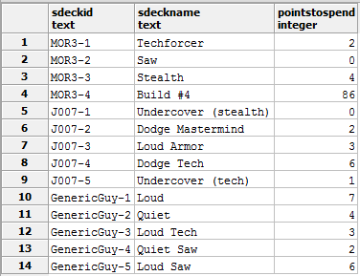
Perk Deck

Create Table Perk_Deck (
PDeckID text Not Null,
PerkDeckName text,
Description text,
PointsToSpend int Not Null,
Primary Key(PDeckID)
);

The Functional Dependencies are based on PDeckID as it is the primary key.

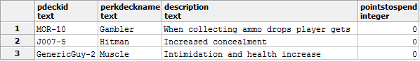

Skill Deck Specifics

Create Table Skill_Deck_Specifics (
SDeckID text Not Null,
PointsMastermind int Not Null,
PointsEnforcer int Not Null,
PointsTechnician int Not Null,
PointsGhost int Not Null,
PointsFugative int Not Null,
Primary Key(SDeckID)
);

The Functional Dependencies are based on SDeckID as it is the primary key.

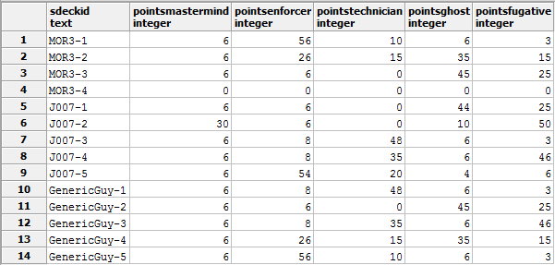

Perk Deck Specifics

Create Table Perk_Deck_Specifics (
PDeckID text Not Null,
PerkDeckName text Not Null,
Description text Not Null,
IsCompleted boolean Not Null,
DeckPartsComplete int Not Null,
Primary Key(PDeckID, PerkDeckName)
);

The Functional Dependencies are based on the composite key PDeckID and PerkDeckName as there can be many perk decks of the same name as they can not be altered in game so they are attatched to the users perk deck ID making them unique.

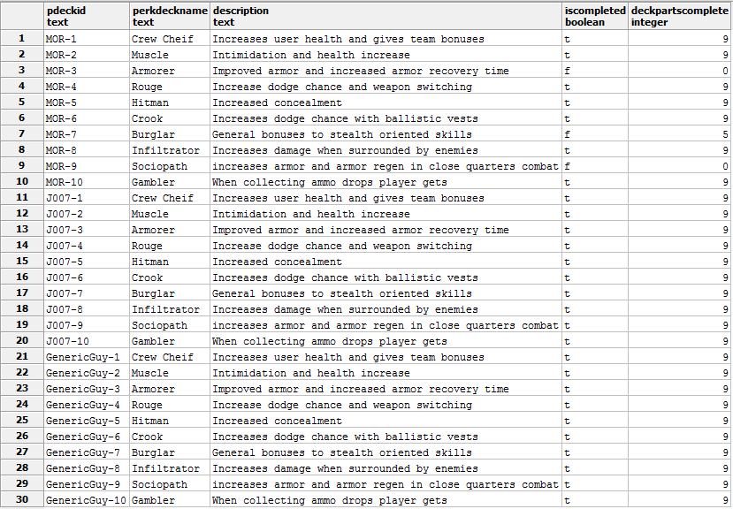

Primary Weapon

Create Table Primary_Weapon (
PrimaryWeapon text Not Null,
WeaponName text Not Null,
GunType text Not Null,
Primary Key(PrimaryWeapon)
);

The Functional Dependencies are based on PrimaryWeapon as it is the primary key.

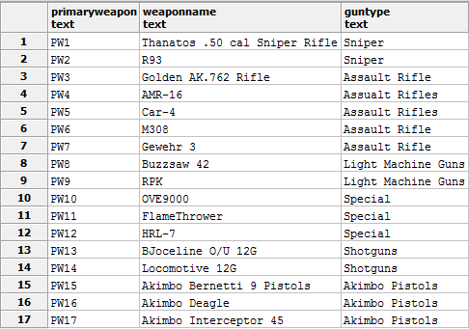

Secondary Weapon

Create Table Secondary_Weapon (
SecondaryWeapon text Not Null,
WeaponName text Not Null,
GunType text Not Null,
Primary Key(SecondaryWeapon)
);

The Functional Dependencies are based on SecondaryWeapon as it is the primary key.

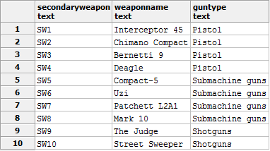

Melee

Create Table Melee (
MeleeID text Not Null,
WeaponName text Not Null,
Primary Key(MeleeID)
);

The Functional Dependencies are based on MeleeID as it is the primary key.
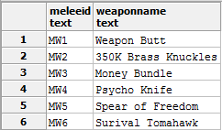

Grenade

Create Table Grenade (
GrenadeID text Not Null,
GrenadeType text Not Null,
Primary Key(GrenadeID)
);

The Functional Dependencies are based on GrenadeID as it is the primary key.

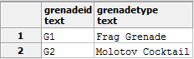

Armor

Create Table Armor (
ArmorID text Not Null,
ArmorName text Not Null,
Description text Not Null,
Primary Key(ArmorID)
);

The Functional Dependencies are based on ArmorID as it is the primary key.

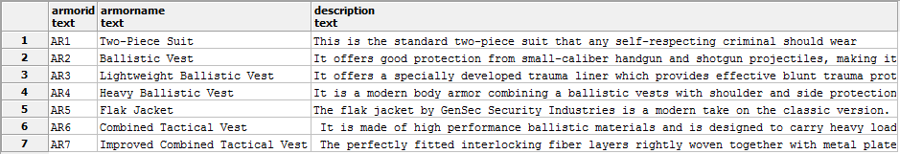

Equipment

Create Table Equipment (
EquipmentID text Not Null,
EquipmentName text Not Null,
Description text Not Null,
Primary Key(EquipmentID)
);

The Functional Dependencies are based on EquipmentID as it is the primary key.

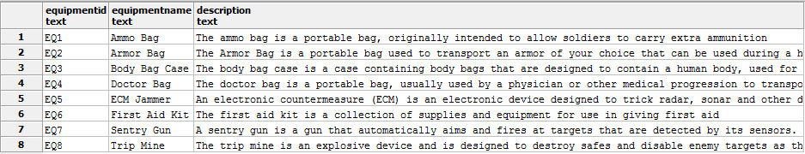

Create Table Mask (
MaskID text Not Null,
MaskName text Not Null,
MaskType text Not Null,
Color text Not Null,
Pattern text Not Null,
Primary Key(MaskID)
);

The Functional Dependencies are based on MaskID as it is the primary key.

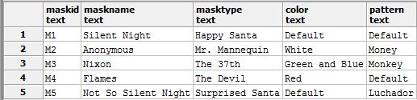

Views

Name and Level

This view is used to display the username, name and levels of the user for a quick view of their overall game progress.

Create View NameLevel
As
Select Distinct Users.Username, Users.PersonName, Character_Level.InfamyLevel, Character_level.Characterlevel
from Users join
Character_level on
Users.Username = Character_Level.Username;

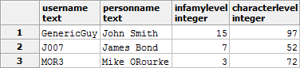

Queries
Primary Gun in use

Queries the gun from options and if a user has it active.
Note: if the guntype is not one that any user has active it will result in a blank query

select Primary_Weapon.PrimaryWeapon, Primary_Weapon.WeaponName, Inventory.Username
from Inventory join
Primary_Weapon on
Primary_Weapon.PrimaryWeapon = Inventory.PrimaryWeapon
where Primary_Weapon.guntype = 'Sniper'

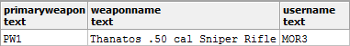
Secondary Gun in use

Queries the gun from options and if a user has it active.
Note: if the guntype is not one that any user has active it will result in a blank query

select Secondary_Weapon.SecondaryWeapon, Secondary_Weapon.WeaponName, Inventory.Username
from Inventory join
Secondary_Weapon on
Secondary_Weapon.SecondaryWeapon = Inventory.PrimaryWeapon
where Secondary_Weapon.guntype = 'Pistol'

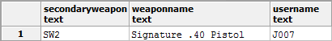

Store Procedures

Change Gun Name

This stored procedure was intended to help the admin change the name of a gun quickly without having to go through the table and change the entity manually.

Create or Replace Function GunNameChange (text, refcursor) returns refcursor as $$
declare
name_gun int := $1;
resultset refcursor := $2;
begin
open resultset for
select PrimaryWeapon, WeaponName
from PrimaryWeapon;
end;
$$
language plpgsql;

NOTE:
Known Problem: Function not quite running correctly.

Security

The two people accessing this database would be the Admin who has full privilege to do any type of modifying to the database and the users who can view various parts but are unable to change anything.

Admin

Create Role Admin
Grant select, insert, update, delete
on all tables in schema public
to Admin

The reason the users do not have more access is that all of their changes are done through the game rather than the database itself calling upon changes via in game commands.

Users

Create Role Users
grant select
on all tables in schema public
to Users

Implementation Notes
The creation of the database was smooth with the major bump in the road being how much of the game would make sense to implement for this project. As the game has hundreds of weapon and mask entities it would be difficult to specify them in sample data and thus only a few were chosen. One of the largest parts of the weapons was the modifications that were able to be done in game was left out due to the vast number of tabs and modifications that could be done to each weapon which was outside the scope of this project. However, the mask customizations were few enough that they were able to be placed into the project with a few examples.

Known Problems
The first currently known problems are issues with the stored procedures that were intentionally meant to be implemented were cut out as the in game commands are largely used to modify the database rather than many stored procedures.
A second issue is that there is a lack of views due to the inventory being the largest source of information as this view gives a good overview of active items the user chose in game to use. Due to this being the largest central entity it is difficult to see everything the user has unlocked unless a specific table is viewed rather than a mixture.
The database is lacking triggers due in two parts, first because I was unable to get them to work and rather than have pieces of not working scrap code I cleaned up the sql and removed them. Second was they did not make as much sense in the database because the Inventory table does not need to trigger anything when being changed, rather it needs to just be updated when the user makes a change.

Future Enhancements
Looking toward the future the addition of the vast amounts of customizations to the weapons would be a great piece to implement into the database adding another layer of complexity. Additionally, a trigger or multiple triggers to activate the addition of a starter character for new users; when a new user logs in for the first time it triggers the database to add them to all the necessary tables.

